Define Strategic Management?
Ans: Strategic management is what managers do to develop the organization’s strategies. It’s an important task involving all the basic management functions—planning, organizing, leading, and controlling.

Define Organization Strategies?
Ans: What are an organization’s strategies? They’re the plans for how the organization will do whatever it’s in business to do, how it will compete successfully, and how it will attract and satisfy its customers in order to achieve its goals.4

Define Business Model?
Ans: One term often used in strategic management is business model, which simply is how a company is going to make money. It focuses on two things: (1) whether customers will value what the company is providing, and (2) whether the company can make any money doing that.5 For instance, Dell pioneered a new business model for selling computers to consumers directly online instead of selling through computer retailers like other manufacturers. Did customers “value” that? Absolutely! Did Dell make money doing it that way? Absolutely! As managers think about strategies, they need to think about the economic viability of their company’s business model.

Define Why is Strategic Management Important(Three)?
- It Results in higher organization performance.
- It Requires that managers examine and adapt to business environment changes.
- It coordinates diverse organizational units, helping them focus on organizational goals.

1. It Results in higher organization performance:
Ans: Research has found a generally positive relationship between strategic planning and performance.7 In other words, it appears that organizations that use strategic management do have higher levels of performance. And that fact makes it pretty important for managers!

2. It Requires that managers examine and adapt to business environment changes:
Ans: Situations will not always remain same, manager should note what thing is in demand or it will be, so produce or start research on that item. Lets suppose: Nokia was the most popular brand among the world, but market Nokia can’t meet market norms. World is moving on android and Nokia was not, So Nokia loss their value and market shares.

3. It coordinates diverse organizational units, helping them focus on organizational goals:
Ans: organizations are complex and diverse. Each part needs to work together toward achieving the organization’s goals; strategic management helps do this. For example, with more than 2.1 million employees worldwide working in various departments, functional areas, and stores, Walmart Stores, Inc., uses strategic management to help coordinate and focus employees’ efforts on what’s important as determined by its goals.

The Strategic Management Process

The strategic management process (see Exhibit 9-1) is a six-step process that encompasses strategy planning, implementation, and evaluation. Although the first four steps describe the planning that must take place, implementation and evaluation are just as important! Even the best strategies can fail if management doesn’t implement or evaluate them properly.

Step 1: Identifying the Organization’s Current Mission,
Goals, and Strategies
Every organization needs a mission—a statement of its purpose.
mission forces managers to identify what it’s in business to do. “The mission of Facebook is “a social utility that connects you with the people around you.”

Step 2: Doing an External Analysis
Ans: Managers do an external analysis so they know, for instance, what the competition is doing, what pending legislation might affect the organization, or what the labor supply is like in locations where it operates. In an external analysis, managers should examine the economic, demographic, political/legal, sociocultural, technological, and global components to see the trends and changes.
Example: Once they’ve analyzed the environment, managers need to pinpoint opportunities that the organization can exploit and threats that it must counteract or buffer against. Opportunities are positive trends in the external environment; threats are negative trends.

Step 3: Doing an Internal Analysis
Ans: internal analysis, which provides important information about an organization’s specific resources and capabilities. An organization’s resources are its assets—financial, physical, human, and intangible—that it uses to develop, manufacture, and deliver products to its customers.
1. Capabilities are its skills and abilities in doing the work activities needed in its business
2. Core Competencies: Both resources and core competencies determine the organization’s competitive weapons.
3. Strength: internal analysis, managers should be able to identify organizational strengths and weaknesses. Any activities the organization does well or any unique resources that it has are called strengths. Weaknesses are activities the organization doesn’t do well or resources it needs but doesn’t possess.
SWOT: It is a mixture of Internal and external Analysis…
Step 4: Formulating Strategies:
Ans: As managers formulate strategies, they should consider the realities of the external environment and their available resources and capabilities in order to design strategies that will help an organization achieve its goals.
Step 5: Implementing Strategies
Once strategies are formulated, they must be implemented. No matter how effectively an organization has planned its strategies, performance will suffer if the strategies aren’t implemented properly.
Step 6: Evaluating Results
The final step in the strategic management process is evaluating results. How effective have the strategies been at helping the organization reach its goals? What adjustments are neces- sary? After assessing the results of previous strategies and determining that changes were needed,
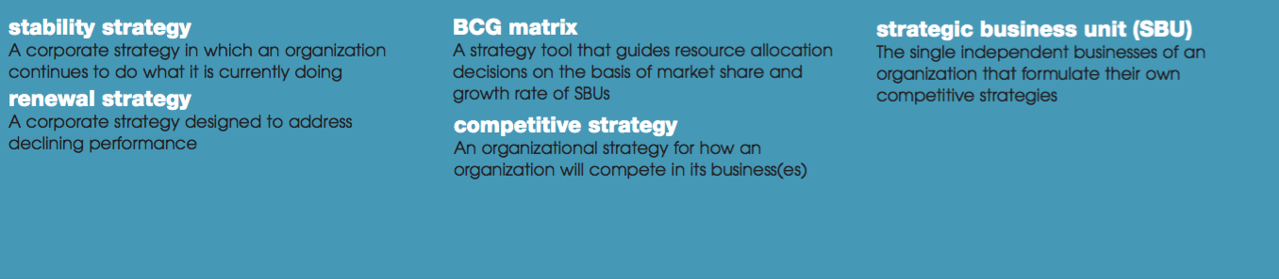

Types of Strategy:
As we said earlier, organizations use three types of strategies: corporate, competitive, and functional. (See Exhibit 9-3.) Top level managers typically are responsible for corporate strategies, middle-level managers for competitive strategies, and lower-level managers for the functional strategies. In this section, we’ll look at corporate strategies.

What Is Corporate Strategy?
Ans: A corporate strategy is one that determines what businesses a company is in or wants to be in, and what it wants to do with those businesses. It’s based on the mission and goals of the organization and the roles that each business unit of the organization will play.
PepsiCo, for instance. Its mission: To be the world’s premier consumer products company focused on convenient foods and beverages.
What Are the Types of Corporate Strategy?
There are three types of Corporate Strategy.
- Growth: A growth strategy is when an organization expands the number of markets served or products offered, either through its current business(es) or through new business(es). Because of its growth strategy, an organization may increase revenues, number of employees, or market share. Organizations grow by using concentration, vertical integration, horizontal integration, or diversification.
- Concentration: using concentration focuses on its primary line of business and increases the number of products offered or markets served in this primary business. Focuses on developing innovative audio products and has become one of the world’s leading manufacturers of speakers for home entertainment, automotive, and pro audio markets with sales of more than $2 billion.
- Vertical integration: A company also might choose to grow by vertical integration, either backward, forward, or both. In backward vertical integration, the organization becomes its own supplier so it can control its inputs. In forward vertical integration, the organization becomes its own distributor and is able to control its outputs
- Horizontal Integration: In this strategy, manufacture don’t built complete things, so it is dependent
- Diversification: Finally, an organization can grow through diversification, either related or unrelated. Related diversification happens when a company combines with other companies in different, but rewell in a challenging environment. Just weeks after taking over as CEO, she lated, industries. Unrelated diversification is when a company combines with firms in different and unrelated industries.
- Strategy: A stability strategy is a corporate strategy in which an organization continues to do what it is currently doing. Examples of this strategy include continuing to serve the same clients by offering the same product or service, maintaining market share, and sustaining the organization’s current business operations. The organization doesn’t grow, but doesn’t fall behind,
- Renewal Strategy: financial issues with huge losses. When an organization is in trouble, something needs to be done. Managers need to develop strategies, called renewal strategies, that address declining performance. The two main types of renewal strategies are retrenchment and turnaround strategies.
      - retrenchment (Short Teams)
      - the turnaround strategy (When an organization’s problems are more serious, more drastic action—the turnaround strategy—is needed. )
- BCG Matrix
    - In this section we compare Market Share vs growth rate, we have four possitbility:
      - Stars (High market rate and high anticipated growth rate),
      - Qustion mark (Low market rate, but High anticipate growth rate)
      - Cash Crows (High market, but low anticipate growth rate)
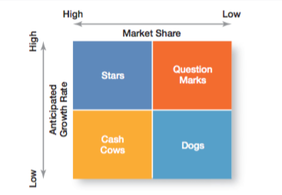
      - Dog: (High how market rate and high low anticipated growth rate),

The Role of Competitive Advantage:
Being Different: Developing an effective competitive strategy requires an understanding of competitive advantage, which is what sets an organization apart that is, its distinctive edge.17 That distinctive edge can come from the organization’s core competencies by doing something that others cannot do or doing it better than others can do it.
Quality as a Competitive Advantage:
Every employee has a responsibility to maintain the high quality of products. If implemented properly, quality can be a way for an organization to create a sustainable competitive advantage.
Sustaining Competitive Advantage:

